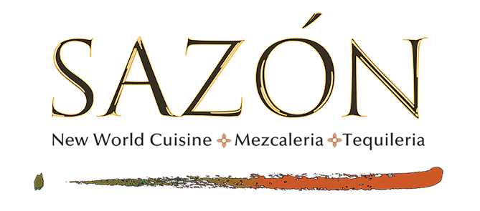

VODKA
Absolut Vodka 12
Angel Fire 12
Beluga Noble Russian Gold Line 45
Belvedere Polish Vodka 14
Chopin Potato Vodka 14
Grey Goose Vodka 14
Hollow Spirits Lavender 13
Ketel One Vodka 12
Stolichnaya 12
Titos Handmade Vodka 12

GIN
Bombay Sapphire Gin 12
Empress 16
Gracias a Dios Agave Gin 18
Hendricks Gin 14
Plymouth 12
Santa Fe Wheelers Gin 14
Sipsmith Dry Gin 14
Tanqueray Gin 12
Uncle Val’s Restorative Gin 14

RUM
Don Q Gran Anejo 12
Mount Gay Rum Eclipse 20
Panama Pacific Rum 23Yr. 20
Ron Abuelo Rum 7 yr. 12
Ron Zacapa 23 yr. 20

VODKA
Absolut Vodka 12
Angel Fire 12
Beluga Noble Russian Gold Line 45
Belvedere Polish Vodka 14
Chopin Potato Vodka 14
Grey Goose Vodka 14
Hollow Spirits Lavender 13
Ketel One Vodka 12
Stolichnaya 12
Titos Handmade Vodka 12

GIN
Bombay Sapphire Gin 12
Empress 16
Gracias a Dios Agave Gin 18
Hendricks Gin 14
Plymouth 12
Santa Fe Wheelers Gin 14
Sipsmith Dry Gin 14
Tanqueray Gin 12
Uncle Val’s Restorative Gin 14

RUM
Don Q Gran Anejo 12
Mount Gay Rum Eclipse 20
Panama Pacific Rum 23Yr. 20
Ron Abuelo Rum 7 yr. 12
Ron Zacapa 23 yr. 20

