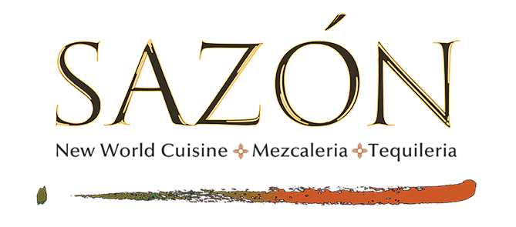

SANGRIA

SANGRIA BLANCA
La Playa Estate Series Sauvignon Blanc, Giffard Wild Strawberry and Rhubarb Liqueurs, Cointreau, Fresh Orange
14

SANGRIA ROJA
Anciano 3 yr. Tempranillo, Spanish Brandy, Grand Marnier,
Apricot Brandy, Fresh Berries and Fresh Orange
14

MARGARITAS

DE LA CASA
Exotico Blanco Tequila, Grandeza Orange,
Fresh Lime, Agave Nectar
14

FLOR DEL DESIERTO
Exotico Blanco Tequila, Grandeza Orange, Prickly Pear Purée,
Fresh Lime, Red Chile Salt Rim
16

TAMARINDO MARGARITA
El Tesoro Blanco, Liquid Alchemist Tamarindo, Cointreau,
Fresh Lime Juice, Red Chile Salt Rim
18

INFIERNO
Chamucos Blanco Tequila, Grandeza Orange, Jalapeno,
Fresh Lime Juice, Agave Nectar, Red Chile Salt Rim
20

CLOONEY COIN
Casamigos Blanco Tequila, Cointreau,
Fresh Lime Juice, Agave Nectar
20

ORO PURO
Casa Noble Añejo Tequila, Grand Marnier,
Fresh Lime Juice, Muddled Orange, Agave Nectar
20

DIAMANTE AZUL
Clase Azul Reposado Tequila, Cointreau,
Fresh Lime Juice, Agave Nectar, Blue Sea Salt Rim
40

CERVEZA

MICHELADA
This popular way to drink beer as served throughout Mexico.
Modelo Especial, House Made Spicy Sangrita Roja,
Fresh Lime Juice, Red Chile Salt Rim
10

Modelo Especial, Mexico City, MX 7
Negra Modelo, Mexico City, MX 7
Pacifico, Sinaloa, MX 7
Dos Equis Amber, Monterrey (Nuevo León), MX 7
Estrella Damn Daura (gluten free), Madrid, Spain 7
Marble Double White, Albuquerque, NM 7
Santa Fe Brewing '7K' IPA, Santa Fe, NM 7
Chimay Dubbel Red Label, Belgium 10
Xingu Black Lager, Jacarei, Brazil 10

SANGRIA

SANGRIA BLANCA
La Playa Estate Series Sauvignon Blanc, Giffard Wild Strawberry and Rhubarb Liqueurs, Cointreau, Fresh Orange
14

SANGRIA ROJA
Anciano 3 yr. Tempranillo, Spanish Brandy, Grand Marnier,
Apricot Brandy, Fresh Berries and Fresh Orange
14

MARGARITAS

DE LA CASA
Exotico Blanco Tequila, Grandeza Orange,
Fresh Lime, Agave Nectar
14

FLOR DEL DESIERTO
Exotico Blanco Tequila, Grandeza Orange, Prickly Pear Purée,
Fresh Lime, Red Chile Salt Rim
16

TAMARINDO MARGARITA
El Tesoro Blanco, Liquid Alchemist Tamarindo, Cointreau,
Fresh Lime Juice, Red Chile Salt Rim
18

INFIERNO
Chamucos Blanco Tequila, Grandeza Orange, Jalapeno,
Fresh Lime Juice, Agave Nectar, Red Chile Salt Rim
20

CLOONEY COIN
Casamigos Blanco Tequila, Cointreau,
Fresh Lime Juice, Agave Nectar
20

ORO PURO
Casa Noble Añejo Tequila, Grand Marnier,
Fresh Lime Juice, Muddled Orange, Agave Nectar
20

DIAMANTE AZUL
Clase Azul Reposado Tequila, Cointreau,
Fresh Lime Juice, Agave Nectar, Blue Sea Salt Rim
40

CERVEZA

MICHELADA
This popular way to drink beer as served throughout Mexico.
Modelo Especial, House Made Spicy Sangrita Roja,
Fresh Lime Juice, Red Chile Salt Rim
10

Modelo Especial, Mexico City, MX 7
Negra Modelo, Mexico City, MX 7
Pacifico, Sinaloa, MX 7
Dos Equis Amber, Monterrey (Nuevo León), MX 7
Estrella Damn Daura (gluten free), Madrid, Spain 7
Marble Double White, Albuquerque, NM 7
Santa Fe Brewing '7K' IPA, Santa Fe, NM 7
Chimay Dubbel Red Label, Belgium 10
Xingu Black Lager, Jacarei, Brazil 10

