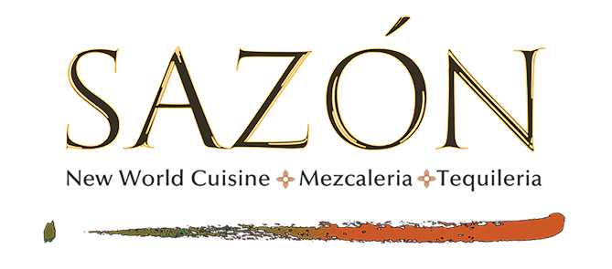

SPECIALTY COCKTAILS

THE SQUEEZE
Exotico Blanco Tequila, Grandeza Orange, Fresh Grapefruit Juice, Hawaiian Black Lava Salt Rim, Grapefruit Wedge
14

SAZONRITA
Sombra Joven Mezcal, Grandeza Orange, Muddled Cucumber, Fresh Lime, Red Chile Salt Rim, Lime Wedge
16

THE HOMEGROWN
Teremana Tequila Blanco, Fresh Lemon, Muddled Herbs, Fever Tree Mediterranian Tonic, Grapefruit Twist
16

DIEGO RIVERA
Xicaru Reposado Mezcal, Giffard Lichi-Li,
Rumhaven Coconut Water, Passion Fruit Puree, Edible Orchid
16

FRIDA KAHLO
Pinnacle Gin, Gruet Rose Sparkling Wine, Giffard Raspberry, Rosewater, Fresh Lemon Juice, Lemon Twist
16

RESPIRO DE FE
Hollow Spirits Lavender Vodka, Black Tea, Giffard Raspberry, Giffard Ginger, Fresh Lemon Juice, Lavender Bitters
16

BRISA DE HIERBAS
Pinnacle Gin, Giffard Elderflower, Fresh Lemon Juice,
Green Chartreuse, Fresh Rosemary
18

MANHATTAN GOES LATIN
Knob Creek Rye Whiskey, Carpano Antica Vermouth, Orange and Chocolate Mole Bitters, Luxardo Cherry, Orange Twist
20

SPECIALTY COCKTAILS

THE SQUEEZE
Exotico Blanco Tequila, Grandeza Orange, Fresh Grapefruit Juice, Hawaiian Black Lava Salt Rim, Grapefruit Wedge
14

SAZONRITA
Sombra Joven Mezcal, Grandeza Orange, Muddled Cucumber, Fresh Lime, Red Chile Salt Rim, Lime Wedge
16

THE HOMEGROWN
Teremana Tequila Blanco, Fresh Lemon, Muddled Herbs, Fever Tree Mediterranian Tonic, Grapefruit Twist
16

DIEGO RIVERA
Xicaru Reposado Mezcal, Giffard Lichi-Li,
Rumhaven Coconut Water, Passion Fruit Puree, Edible Orchid
16

FRIDA KAHLO
Pinnacle Gin, Gruet Rose Sparkling Wine, Giffard Raspberry, Rosewater, Fresh Lemon Juice, Lemon Twist
16

RESPIRO DE FE
Hollow Spirits Lavender Vodka, Black Tea, Giffard Raspberry, Giffard Ginger, Fresh Lemon Juice, Lavender Bitters
16

BRISA DE HIERBAS
Pinnacle Gin, Giffard Elderflower, Fresh Lemon Juice,
Green Chartreuse, Fresh Rosemary
18

MANHATTAN GOES LATIN
Knob Creek Rye Whiskey, Carpano Antica Vermouth, Orange and Chocolate Mole Bitters, Luxardo Cherry, Orange Twist
20

