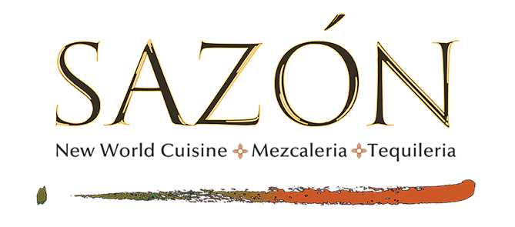

SHERRY
Gonzales Byass Nectar Pedro Ximenez Sherry 14
Tio Pepe Fino Sherry 14

PORT
Dows Tawny Port 10 yr. 14
Dows Tawny Port 20 yr. 22
Fonseca Old Tawny Port 20 yr. 18
Grahams Old Tawny Port 40 yr. 55

BRANDY
Camus Pere et Fils Cognac Elegance 50
D'usse Cognac VSOP 20
Gran Duque de Alba Brandy 20
Sempe Armagnac Grande Reserve 50
Sempe Armagnac 1962 100
Tesseron Cognac XO Perfection Lot 1953 80
Tesseron Cognac XO Exception Lot 1929 200

LIQUER
1921 Cream Liqueur 12
Ancho Reyes 15
Chartreaux Peres Green Label 40
Chartreaux Peres Yellow Label 40
Cointreau 15
Disaronno Amaretto 12
Fernet Branca 12
Frangelico 14
Grand Marnier 14
Hacienda Chihuahua Sotol Chocolate 12
Marolo Grappa Moscato 20
Rumchata 12
St. Germaine 14
Sunora Bacanora Chocolate 15

SHERRY
Gonzales Byass Nectar Pedro Ximenez Sherry 14
Tio Pepe Fino Sherry 14

PORT
Dows Tawny Port 10 yr. 14
Dows Tawny Port 20 yr. 22
Fonseca Old Tawny Port 20 yr. 18
Grahams Old Tawny Port 40 yr. 55

BRANDY
Camus Pere et Fils Cognac Elegance 50
D'usse Cognac VSOP 20
Gran Duque de Alba Brandy 20
Sempe Armagnac Grande Reserve 50
Sempe Armagnac 1962 100
Tesseron Cognac XO Perfection Lot 1953 80
Tesseron Cognac XO Exception Lot 1929 200

LIQUER
1921 Cream Liqueur 12
Ancho Reyes 15
Chartreaux Peres Green Label 40
Chartreaux Peres Yellow Label 40
Cointreau 15
Disaronno Amaretto 12
Fernet Branca 12
Frangelico 14
Grand Marnier 14
Hacienda Chihuahua Sotol Chocolate 12
Marolo Grappa Moscato 20
Rumchata 12
St. Germaine 14
Sunora Bacanora Chocolate 15

